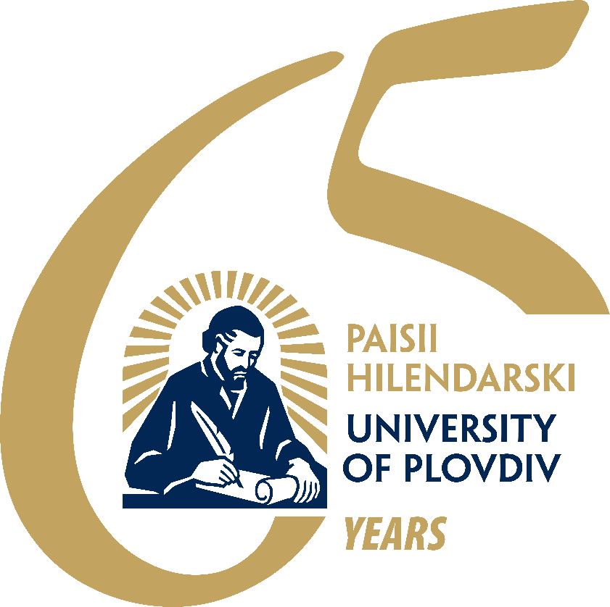

CALL FOR PAPERS

Dear colleagues,

It is our pleasure to invite you to the

ACADEMIC CONFERENCE WITH INTERNATIONAL PARTICIPATION
PAISII READINGS 2026
The academic forum will take place on 5th – 7th November 2026.
The application deadline is 14 September 2026. Please use the email address associated with your preferred panel.

The following panels shape up the conference framework:

1. Metamorphoses of the Laconic – the Short Literary Genres
Please send your abstracts for this panel to this address: pch2026-lit@abv.bg

2. Slavic Languages, Literatures, and Cultures
Please send your abstracts for this panel to this address: pchetenia.slav@gmail.com

3. English as/and the unbearable lightness of being: language, literature, culture, translation
Please send your abstracts for this panel to this address: bozhidara_boneva@uni-plovdiv.bg

4. The Balkans: Languages and Cultures
Please send your abstracts for this panel to this address: s_valchanova@uni-plovdiv.bg

5. Current Trends in the Development of the Contemporary Bulgarian Language
Please send your abstracts for this panel to this address: vidralska@gmail.com

6. Langue, littérature, communication interculturelle
Please send your abstracts for this panel to this address: z_nedeltcheva@uni-plovdiv.bg

7. Sprache, Literatur, interkulturelle Kommunikation
Please send your abstracts for this panel to this address: stanislava_ilieva@uni-plovdiv.bg

8. Lengua, literatura y comunicación intercultural
Please send your abstracts for this panel to this address: v_nenkova@uni-plovdiv.bg

9. Lingua, letteratura e comunicazione interculturale
Please send your abstracts for this panel to this address: z_nedeltcheva@uni-plovdiv.bg

10. Русский язык, литература, культура: диалог с временем
Please send your abstracts for this panel to this address: rus-conf.pu@abv.bg

11. “中文+”视角下的国际中文教育的未来发展趋势 (Future Development Trends in International Chinese Language Education from the “Chinese+” Perspective)
Please send your abstracts for this panel to this address: wangying@uni-plovdiv.bg

12. Roman Jakobson – the Theorist, the Innovator, the Reformer
Please send your abstracts for this panel to this address: e.tilev@uni-plovdiv.bg

13. A Round Table on the Topic: “And at Dawn the Day Begins”, or On the First New Bulgarian Literary Manifestations
Please send your abstracts for the round table to this address: dpivanova@uni-plovdiv.bg

Working languages for the conference are all Slavic languages, English, German, French, Spanish, Italian and Chinese.

Conference papers will be published in the Faculty of Philology Research Papers series (https://ntffpu.uni-plovdiv.bg).
The edition is peer-reviewed. It is referenced in Google Scholar, WorldCat, CEEOL, COBISS, НАЦИД.

No participation fee is required.

